LLM Gateway
Notes LLMStudio Presentation:
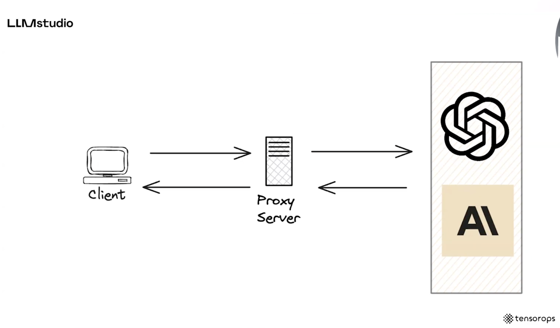
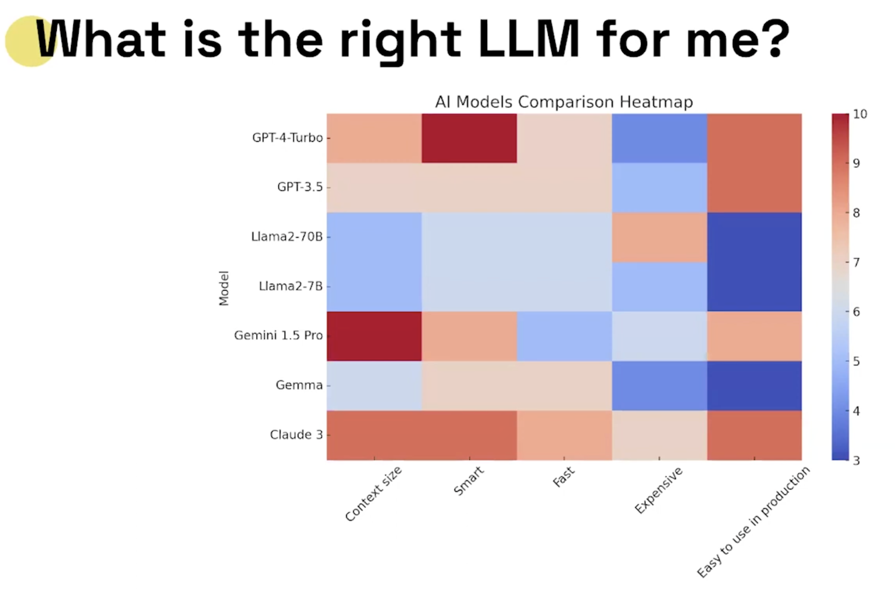

Fine-tuning Prompt cycle
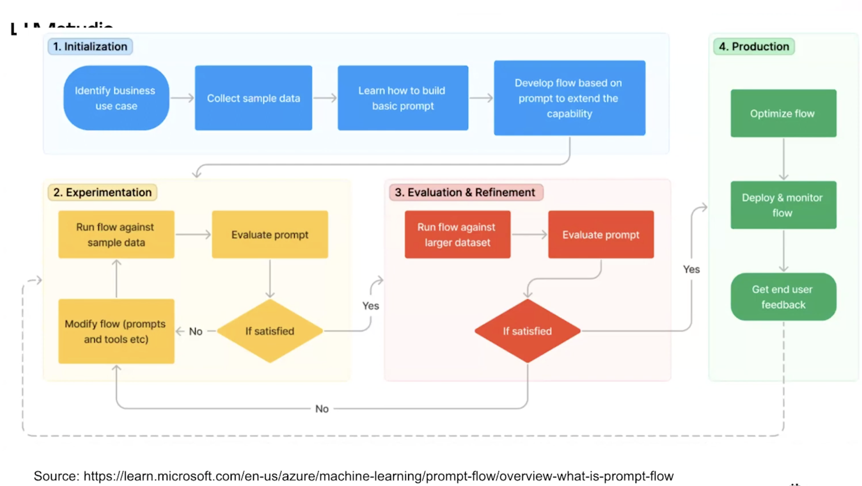

Langchain tool: kinda LLM proxy – LangSmith: Evaluate past performance to see how they perform
Abstract myself and putting the logging will allows us to make smart analysis
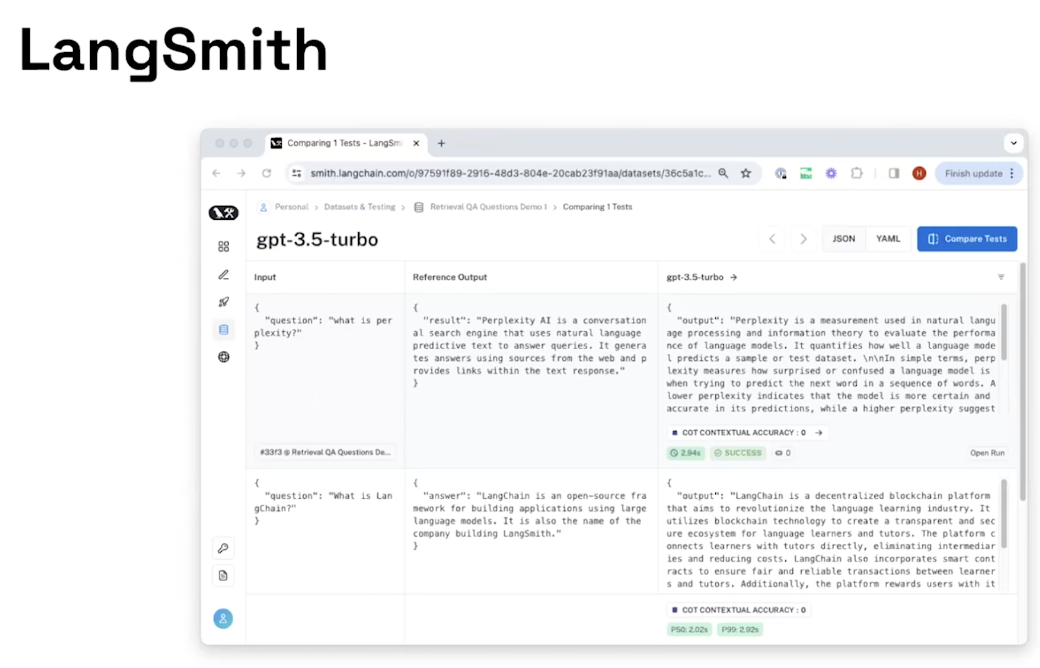

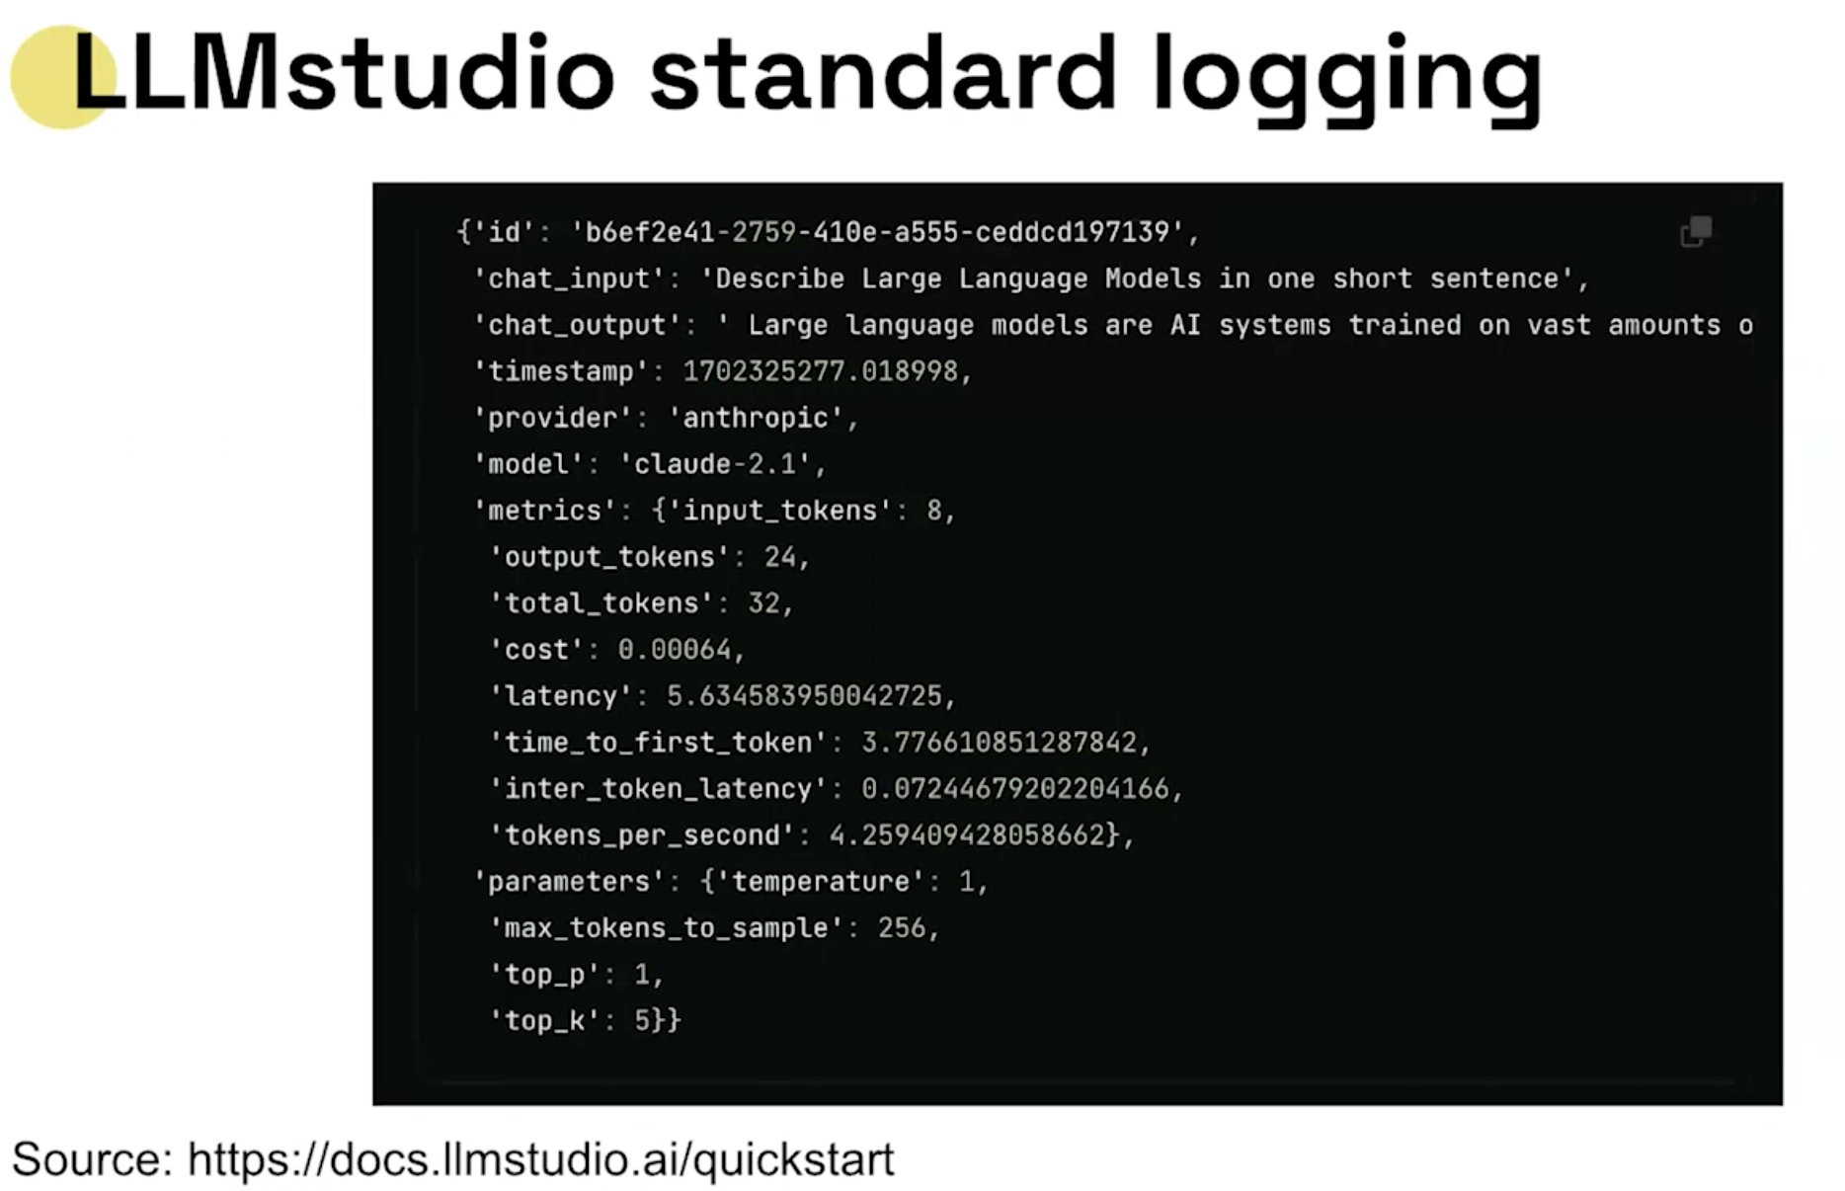

If have event-driven architecture
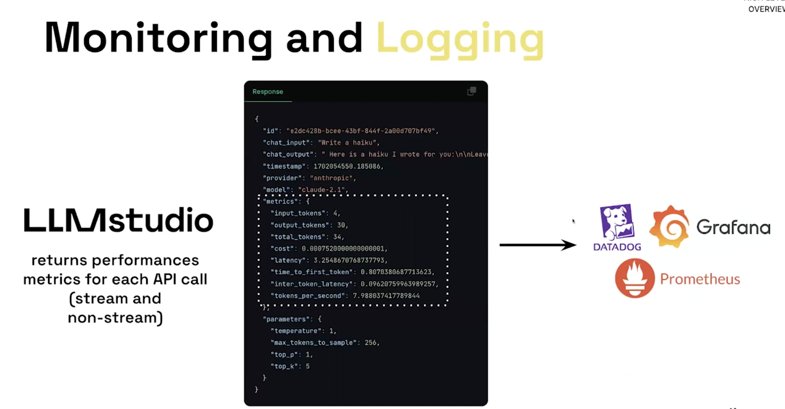

Build our own monitoring pipeline
Visibility : optimsation of our system
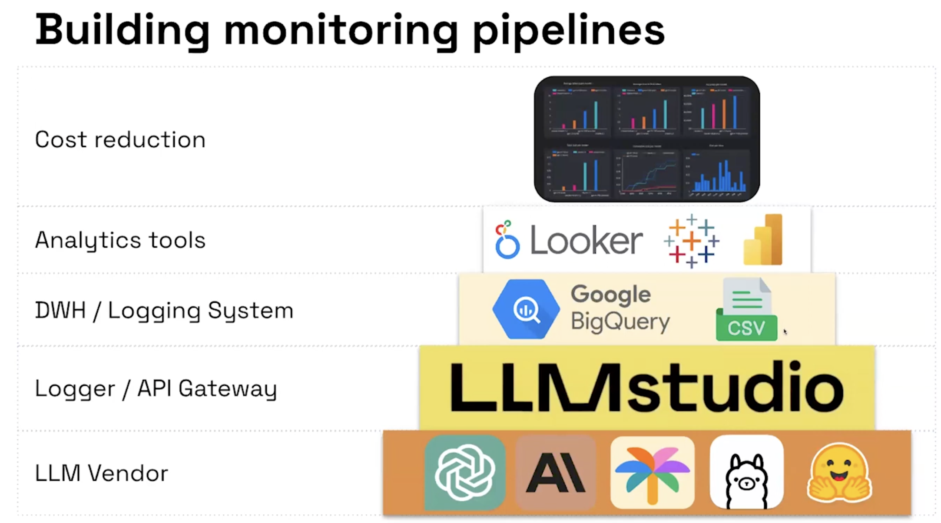
How use this Proxy at Scale:
Multiple clients – bottle neck
Proxy that’s contenarise – automatic load balancer – Scaling policy – Multiple the number of proxies – good way to Scale proxy practice - Deploy to Kubernetes an scale horizontally
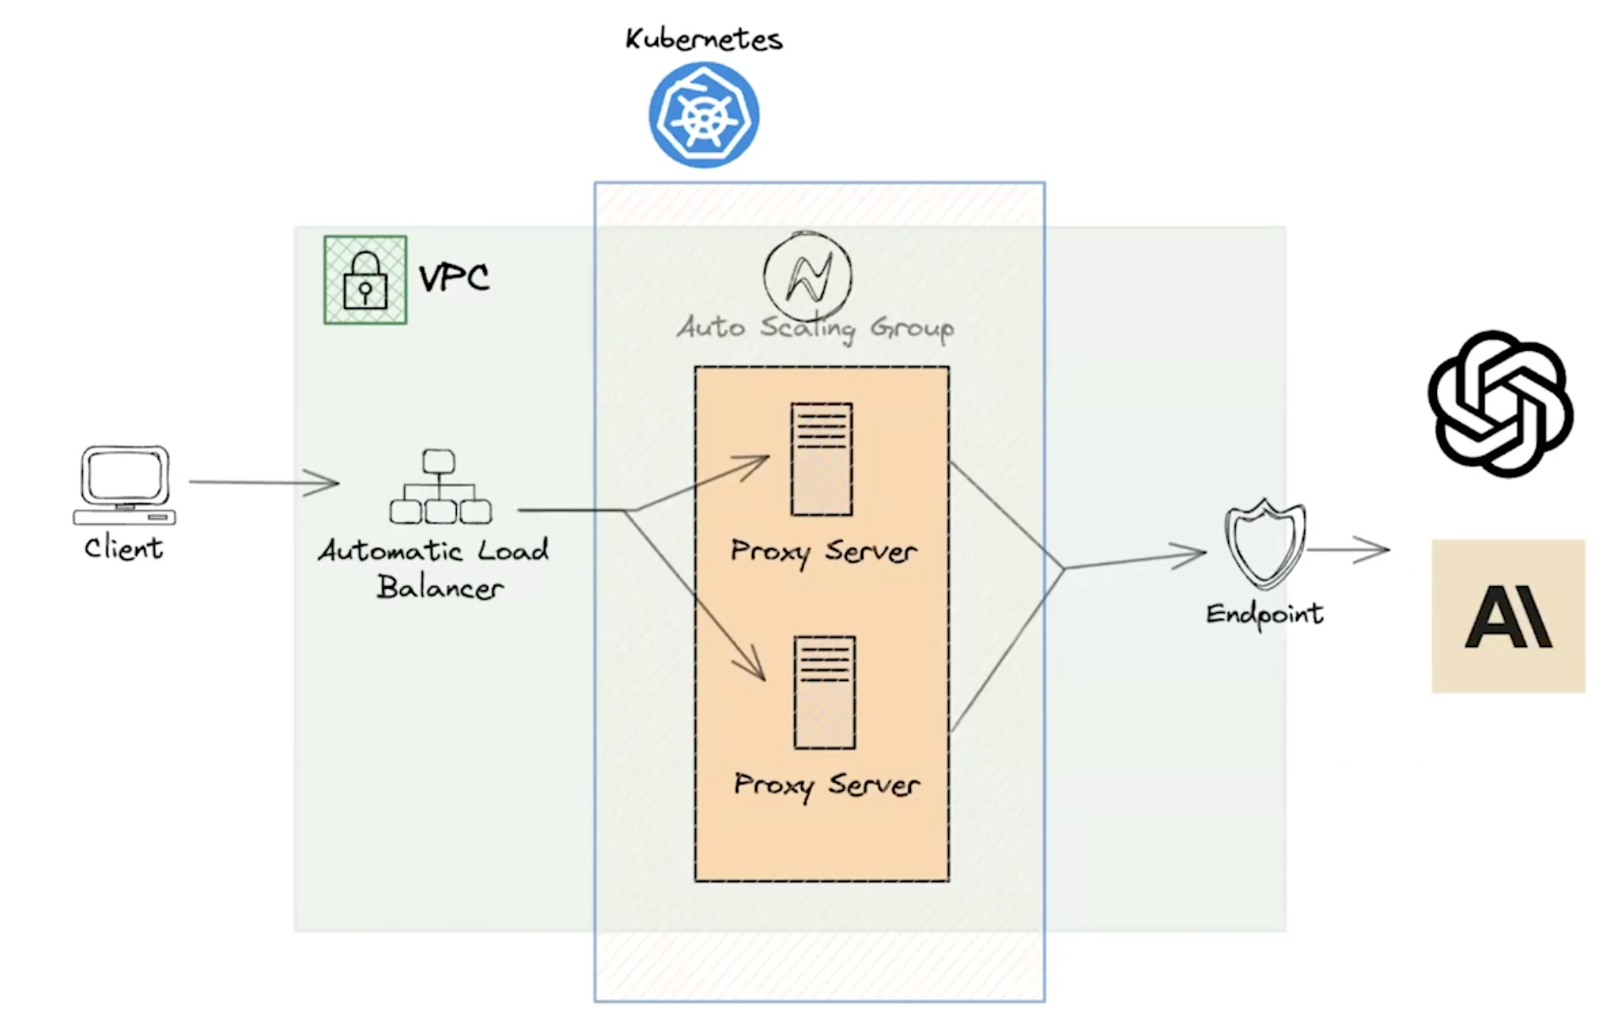
ARCHITECTUE OF AN LLM GATEWAY
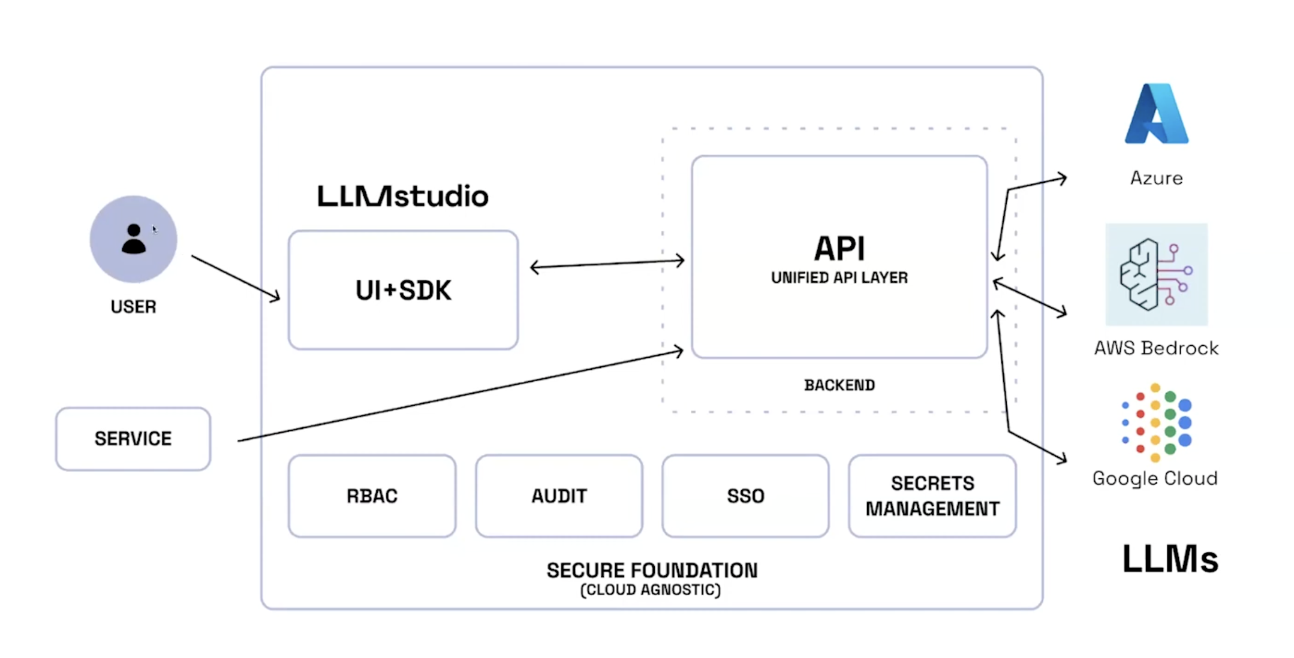

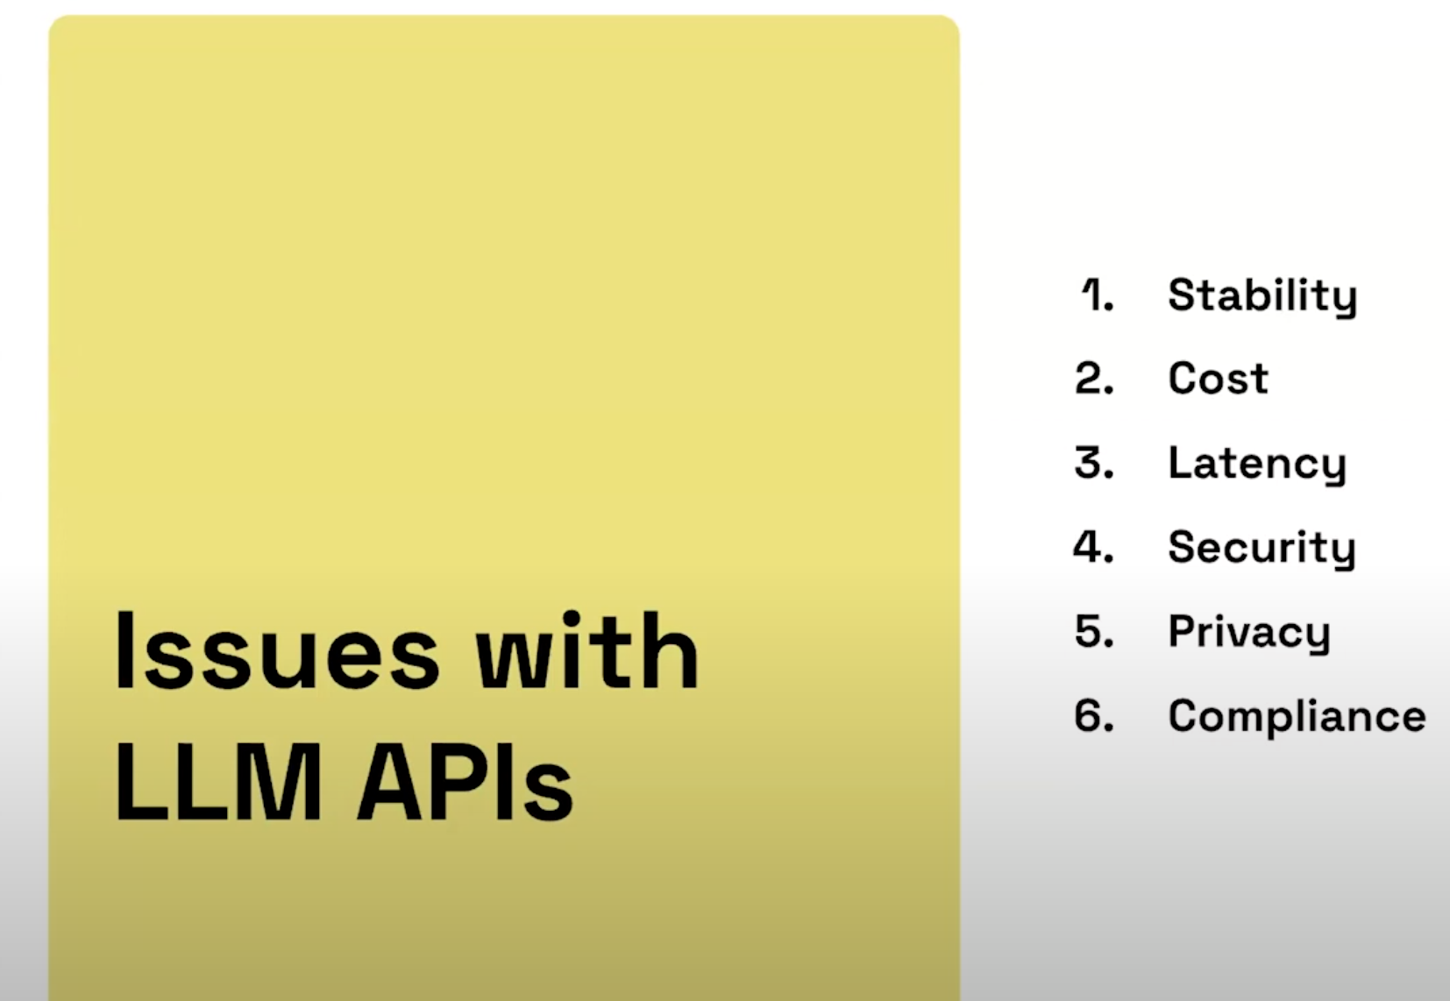

Solutions:
1. Prompt Property Evaluation
Evaluate different prompt properties that could be used to make routing decisions to different LLMs.
First I would like to start by saying that I approached this solution in a methodical and product-minded way rather building a model, that’s way took me more time. I always tend to evaluate my solution to deliver a business feature.
My framework is “Evaluate -> Experiment -> Recommend” pipeline.

To begin with, I listed the most common prompt properties and evaluate for basic routing. I’ll continue adding more to make the routing more robust.
- Complexity level: Simple, Moderate, Complex -> class PromptCoplexity
- Domain classification -> PromptDomain:
  - General,
  - Code,
  - Math,
  - Creative,
  - Analysis,
  - Translation
- Feature detection -> class PromptAnalysis:
  - Tokens and Words length
  - Prompt Complexity
  - Prompt Domain
  - Code patterns (has_code) – Boolean detection
  - Math expressions (has_math) – Boolean detection
  - Questions (has_questions)
  - Urgency indicators: ‘ASAP’, ‘Urgent’, ‘Quick’, ‘Emergency’ -> List[str]
- User priority:
  - Cost,
  - SPeed,
  - Quality,
  - Balanced

Deploying 3 openai models:
o3 includes significant improvements on quality and safety while supporting the existing features of o1 and delivering comparable or better performance through its integration and support of the newest APIs and reasoning features.

Key capabilities
- Multiple APIs support: o3 is available in Responses API and Chat Completions API with Responses API supporting seamless integration with multiple tools and enhanced transparency with the reasoning summary as part of the model output.
- Reasoning summary: In the Responses API, o3 now supports reasoning summary in its output providing more insights into its thinking process. This enhances the explainability and the effectiveness of the resulting actions and tools that leverage the insights for even better outcomes.
- Multimodality: With enhanced vision analysis capabilities, o3 expands its reasoning capability to process and analyze visual data, extracting valuable insights and generating comprehensive text outputs. This is supported in both Responses API and Chat Completions API.
- Full tools support includes parallel tools calling: o3 is the first reasoning model with full tools support similar to the mainline models including parallel tool calling. Use o3 for the next generation of agentic solutions. This capability is supported in both Responses API and Chat Completions API.

Model Variants
- o4-mini: The most efficient reasoning model in the o model series, well suited for agentic solutions. Now generally available.
- o3: The most capable reasoning model in the o model series, and the first one to offer full tools support for agentic solutions. Now generally available.
- o3-mini: A faster and more cost-efficient option in the o3 series, ideal for coding tasks requiring speed and lower resource consumption.
- o1: The most capable model in the o1 series, offering enhanced reasoning abilities. Now generally available.
- o1-mini: A faster and more cost-efficient option in the o1 series, ideal for coding tasks requiring speed and lower resource consumption.
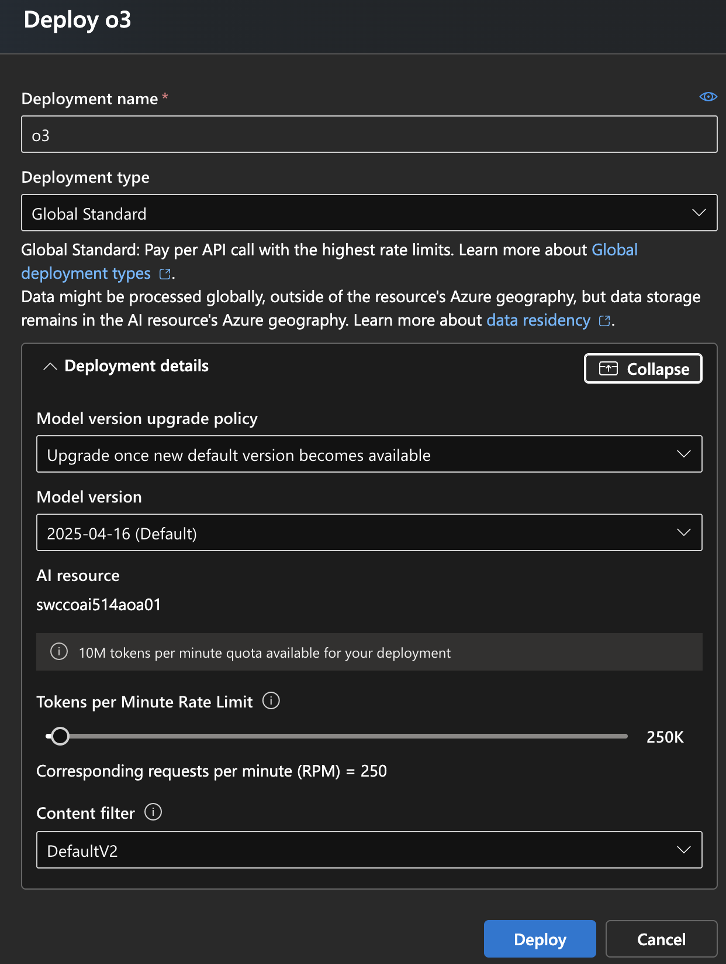
GPT-4o mini enables a broad range of tasks with its low cost and latency, such as applications that chain or parallelize multiple model calls (e.g., calling multiple APIs), pass a large volume of context to the model (e.g., full code base or conversation history), or interact with customers through fast, real-time text responses (e.g., customer support chatbots).
Today, GPT-4o mini supports text and vision in the API, with support for text, image, video and audio inputs and outputs coming in the future. The model has a context window of 128K tokens and knowledge up to October 2023. Thanks to the improved tokenizer shared with GPT-4o, handling non-English text is now even more cost effective.
GPT-4o mini surpasses GPT-3.5 Turbo and other small models on academic benchmarks across both textual intelligence and multimodal reasoning, and supports the same range of languages as GPT-4o. It also demonstrates strong performance in function calling, which can enable developers to build applications that fetch data or take actions with external systems, and improved long-context performance compared to GPT-3.5 Turbo.

o4-mini includes significant improvements on quality and safety while supporting the existing features of o3-mini and delivering comparable or better performance through its integration and support of the newest APIs and reasoning features.

Key Capabilities
- Multiple APIs support: o4-mini is available in Responses API and Chat Completions API with Responses API supporting seamless integration with multiple tools and enhanced transparency with the reasoning summary as part of the model output.
- Reasoning summary: In the Responses API, o4-mini now supports reasoning summary in its output providing more insights into its thinking process. This enhances the explainability and the effectiveness of the resulting actions and tools that leverage the insights for even better outcomes.
- Multimodality: With the addition of vision input capabilities, o4-mini expands its reasoning capability to process and analyze visual data, extracting valuable insights and generating comprehensive text outputs. This is supported in both Responses API and Chat Completions API.
- Full tools support includes parallel tools calling: o4-mini is the first efficient reasoning model with full tools support similar to the mainline models including parallel tool calling. Use o4-mini for the next generation of agentic solutions. This capability is supported in both Responses API and Chat Completions API.

Model Variants
- o4-mini: The most efficient reasoning model in the o model series, well suited for agentic solutions. Now generally available.
- o3: The most capable reasoning model in the o model series, and the first one to offer full tools support for agentic solutions. Now generally available.
- o3-mini: A faster and more cost-efficient option in the o3 series, ideal for coding tasks requiring speed and lower resource consumption.
- o1: The most capable model in the o1 series, offering enhanced reasoning abilities. Now generally available.
- o1-mini: A faster and more cost-efficient option in the o1 series, ideal for coding tasks requiring speed and lower resource consumption.

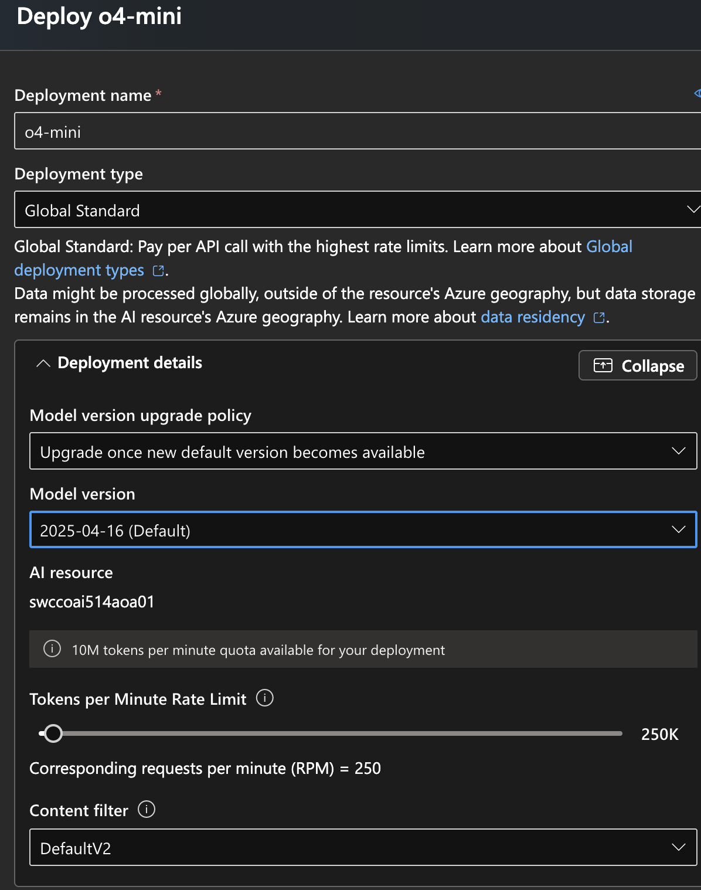
LLM Gateway Deployment Complete!
================================================

## 🌐 Endpoints
- **Web App**: https://llm-gateway-api.azurewebsites.net
- **API Documentation**: https://llm-gateway-api.azurewebsites.net/docs
- **Route Endpoint**: https://llm-gateway-api.azurewebsites.net/api/route
- **Analyze Endpoint**: https://llm-gateway-api.azurewebsites.net/api/analyze
- **Models Endpoint**: https://llm-gateway-api.azurewebsites.net/api/models
- **Test Endpoint**: https://llm-gateway-api.azurewebsites.net/api/test

## 📊 Deployed Resources
- **Resource Group**: llm-gateway-rg
- **App Service Plan**: llm-gateway-plan
- **Web App**: llm-gateway-api
- **Storage Account**: llmgateway88403

## 🤖 LLM Models Configured
1. **o3**: Accuracy Priority - Advanced reasoning for complex STEM tasks
2. **gpt-4o-mini**: Speed Priority - Fast and cost-efficient for high-volume tasks
3. **o4-mini**: Cost Priority - Balance between performance and cost

## 🔧 Next Steps
1. **Set up Azure OpenAI**: Create Azure OpenAI resource and deploy models
2. **Update app settings**: Add your Azure OpenAI endpoint and API key
3. **Deploy code**: Deploy your application code to the web app
4. **Test routing**: Test the intelligent routing with different prompts

### Quick Commands:
# Deploy code (if using local deployment):
az webapp deployment source config-zip --name llm-gateway-api --resource-group llm-gateway-rg --src app.zip

🎯 LLM Gateway is ready!

Endpoints:
- Main API: https://llm-gateway-api.azurewebsites.net/
- Interactive Docs: https://llm-gateway-api.azurewebsites.net/docs
- Health Check: https://llm-gateway-api.azurewebsites.net/
- Models Info: https://llm-gateway-api.azurewebsites.net/api/models

Architecture to Evaluate Different Prompt Properties
- Prompt analysis: which analyses prompt characteristics
- Smart Routing Logic: which routes to optimal models based on analysis
- FastApi Gateway: Production-ready API for real-time routing
- Azure Integration: which I used to deploy and integrated with Azure OpenAI
The Key feature are :
- Multi-Property analysis: Complexity, Domain, Length, Feature, and Urgency
- Intelligent routing: Cost, Speeed, and Quality Optimization

📁 Files Created for Point 1

Core Application Files:
- app.py - Main FastAPI application with 5 endpoints
- src/prompt_analyzer.py - Core routing logic and prompt analysis
- src/models.py - Data models and enums for prompt properties
- src/routing_engine.py - Routing orchestration and model selection
- src/__init__.py - Package initialization

Configuration Files:
- requirements.txt - Dependencies (FastAPI, uvicorn, pydantic, requests)
- startup.sh - Azure App Service startup script
- azure_deploy.sh - Azure deployment script

Testing Files:
- tests/test_prompt_analyzer.py - Unit tests for prompt analysis and routing

Why DistilBERT was chosen

It’s the optimal choice for this LLM routing task because it provides the perfect balance of performance for text classification. As a distilled version of BERT, retained 97% of BERT’s performance while being 60% smaller and 60% faster, making it ideal for real-time routing decisions. DistilBERT is specifically designed for understanding and categorizing text, which is exactly what we need for smart prompt routing. Its pre-trained language understanding allows to capture semantic nuances that rule-based systems miss, while its compact size ensure low-latency inferences suitable for production deployment.
Step-by-step to run the fine-tuning process
- src/dataset_generator.py
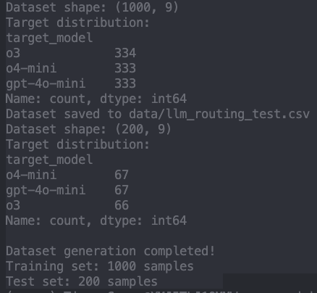
- Fine-tune the DistilBert Model
- src/distilbert_finetuner.py
- After executing:
python3 -c "from src.distilbert_finetuner import DistilBERTFineTuner; import pandas as pd; df = pd.read_csv('data/llm_routing_train.csv'); ft = DistilBERTFineTuner(); cv_results = ft.cross_validate(df, k_folds=3); print('Cross-validation completed!')"

- Cross-Validation Results:
- Accuracy: 1.0000 ± 0.0000
- F1-Macro: 1.0000 ± 0.0000
- F1-Weighted: 1.0000 ± 0.0000
- Cross-validation completed!
- `src/evaluation_framework.py`
Note: run the full pipeline: run_fine_tuning.py
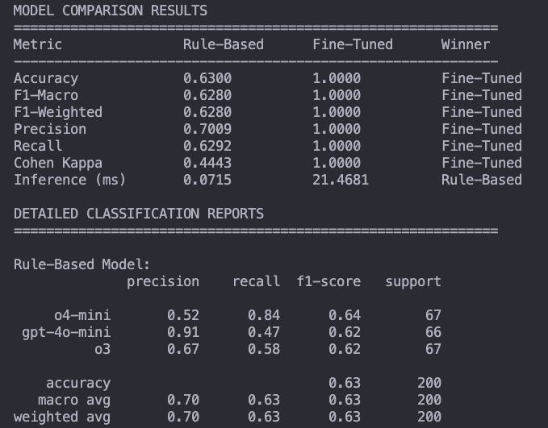
PERFORMANCE COMPARISON
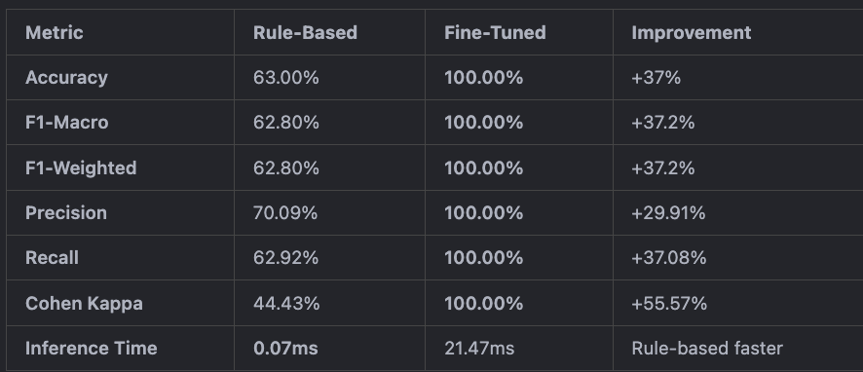

Key Insights:
- 🎯 Perfect Accuracy: Fine-tuned model achieves 100% accuracy vs 63% for rule-based
- ⚡ Speed Trade-off: Rule-based is ~300x faster (0.07ms vs 21ms)
- 🧠 Semantic Understanding: Fine-tuned model captures complex patterns that rules miss
- 🚀 GPU Acceleration: Training completed in ~1.5 minutes vs ~15 minutes on CPU

SUMMARY

✅ Step 1: Dataset Generation
- Generated 1,000 training samples + 200 test samples
- Balanced distribution across 3 models
- Synthetic prompts with realistic complexity

✅ Step 2: Fine-tuning with GPU
- Used Apple Silicon M3 Pro GPU (MPS)
- 100% accuracy achieved in 3 epochs
- Training time: ~3 minutes (vs ~15 minutes on CPU)

✅ Step 3: Model Evaluation
- Comprehensive comparison between approaches
- Fine-tuned model significantly outperforms rule-based
- Detailed classification reports generated

1. API Development
Write an API for the LLM Gateway team to test one of the experiments (either prompt engineering or fine-tuning).
After doing testing and comparing the results fine-tuning won.

Why Fine-tuning Wins at Scale:
- Rule-based systems become unmanageable with 30 models (exponential complexity)
- Fine-tuning provides semantic understanding that rules cannot capture
- Automatic improvement vs manual rule maintenance
- Single model efficiency vs complex rule engine
- Adaptability to new models and use cases

FIRST TIME ON SUNDAY RUN DEPLOY THE APP AND VERIFY ALL AZURE RESOURCES ARE CREATES

Comments for presentation
ROuteLLM: OpenSource framework
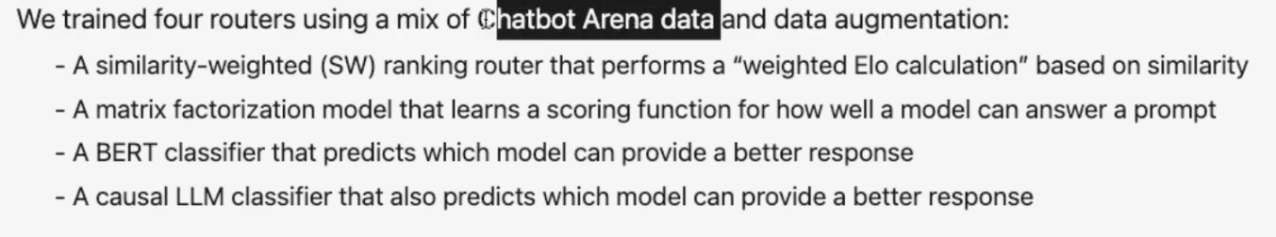
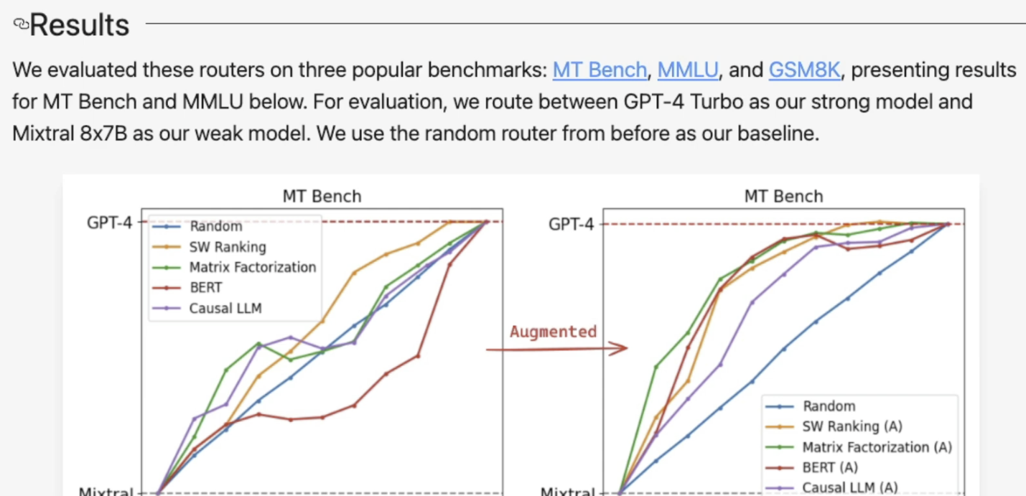

If Asked About Open Source:
"I considered open-source models like Llama, Mistral, and local deployments. However, for an enterprise LLM Gateway, the operational complexity of managing multiple open-source models would have been significant. The routing system's value is in its intelligence, not model hosting - so I chose to focus on the core innovation."

If Asked About Cost:
"The assignment focused on smart routing optimization - which actually reduces costs by directing queries to the most cost-effective model. The routing logic I built can save 60-80% on costs by using cheaper models for simple tasks and expensive models only when needed."

If Asked About Vendor Lock-in:
"The architecture I designed is model-agnostic. The routing logic, prompt analysis, and API structure are completely independent of the underlying models. We can easily add open-source models later by simply updating the model configuration - the core intelligence remains the same."
Future Vision
The next phase would be a hybrid approach:
- OpenAI models for critical, high-accuracy tasks
- Open-source models for cost-sensitive, high-volume tasks
- Custom fine-tuned models for domain-specific use cases
- The routing system intelligently chooses the best option"

Phrase for closing :
The choice of OpenAI models wasn't about limiting options - it was about maximizing the value of the smart routing innovation. The real competitive advantage is in the intelligent routing logic, not the underlying models. This approach lets us focus on what matters most: building the best possible routing system for enterprise users."

